Waterfall Model design

Requirement Gathering and analysis: All possible requirements of the system to be developed are captured in this phase and documented in a requirement specification doc.

System Design: The requirement specifications from first phase are studied in this phase and system design is prepared. System Design helps in specifying hardware and system requirements and also helps in defining overall system architecture.

Implementation: With inputs from system design, the system is first developed in small programs called units, which are integrated in the next phase. Each unit is developed and tested for its functionality which is referred to as Unit Testing.

Integration and Testing: All the units developed in the implementation phase are integrated into a system after testing of each unit. Post integration the entire system is tested for any faults and failures.

Deployment of system: Once the functional and non functional testing is done, the product is deployed in the customer environment or released into the market.

Maintenance: There are some issues which come up in the client environment. To fix those issues patches are released. Also to enhance the product some better versions are released. Maintenance is done to deliver these changes in the customer environment.

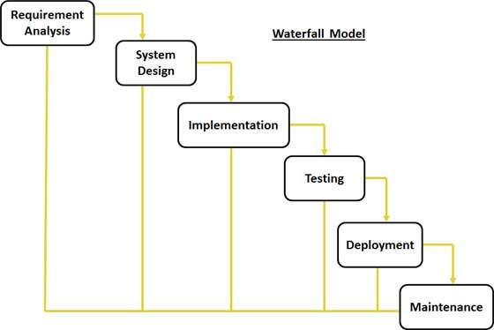

Waterfall Model Application

Every software developed is different and requires a suitable SDLC approach to be followed based on the internal and external factors. Some situations where the use of Waterfall model is most appropriate are:

* Requirements are very well documented, clear and fixed.
* Product definition is stable.
* Technology is understood and is not dynamic.
* There are no ambiguous requirements.
* Ample resources with required expertise are available to support the product.
* The project is short.

Advantage

The advantage of waterfall development is that it allows for departmentalization and control. A schedule can be set with deadlines for each stage of development and a product can proceed through the development process model phases one by one.

Development moves from concept, through design, implementation, testing, installation, troubleshooting, and ends up at operation and maintenance. Each phase of development proceeds in strict order.

Disadvantage

The disadvantage of waterfall development is that it does not allow for much reflection or revision. Once an application is in the testing stage, it is very difficult to go back and change something that was not well-documented or thought upon in the concept stage.

## V- Model design

Under V-Model, the corresponding testing phase of the development phase is planned in parallel. So there are Verification phases on one side of the .V. and Validation phases on the other side. Coding phase joins the two sides of the V-Model.

The below figure illustrates the different phases in V-Model of SDLC.

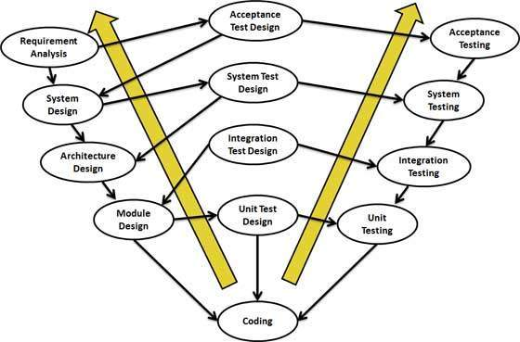

* **Business Requirement Analysis:** This is the first phase in the development cycle where the product requirements are understood from the customer perspective. This phase involves detailed communication with the customer to understand his expectations and exact requirement. This is a very important activity and need to be managed well, as most of the customers are not sure about what exactly they need. The acceptance test design planning is done at this stage as business requirements can be used as an input for acceptance testing.
* **System Design:** Once you have the clear and detailed product requirements, it.s time to design the complete system. System design would comprise of understanding and detailing the complete hardware and communication setup for the product under development. System test plan is developed based on the system design. Doing this at an earlier stage leaves more time for actual test execution later.
* **Architectural Design:** Architectural specifications are understood and designed in this phase. Usually more than one technical approach is proposed and based on the technical and financial feasibility the final decision is taken. System design is broken down further into modules taking up different functionality. This is also referred to as High Level Design (HLD).

The data transfer and communication between the internal modules and with the outside world (other systems) is clearly understood and defined in this stage. With this information, integration tests can be designed and documented during this stage.

* **Module Design:** In this phase the detailed internal design for all the system modules is specified, referred to as Low Level Design (LLD). It is important that the design is compatible with the other modules in the system architecture and the other external systems. Unit tests are an essential part of any development process and helps eliminate the maximum faults and errors at a very early stage. Unit tests can be designed at this stage based on the internal module designs.

## V- Model Application

V- Model application is almost same as waterfall model, as both the models are of sequential type. Requirements have to be very clear before the project starts, because it is usually expensive to go back and make changes. This model is used in the medical development field, as it is strictly disciplined domain. Following are the suitable scenarios to use V-Model:

* Requirements are well defined, clearly documented and fixed.
* Product definition is stable.
* Technology is not dynamic and is well understood by the project team.
* There are no ambiguous or undefined requirements.
* The project is short.

## Spiral Model design

The spiral model has four phases. A software project repeatedly passes through these phases in iterations called Spirals.

* **Identification:** This phase starts with gathering the business requirements in the baseline spiral. In the subsequent spirals as the product matures, identification of system requirements, subsystem requirements and unit requirements are all done in this phase.

This also includes understanding the system requirements by continuous communication between the customer and the system analyst. At the end of the spiral the product is deployed in the identified market.

* **Design:** Design phase starts with the conceptual design in the baseline spiral and involves architectural design, logical design of modules, physical product design and final design in the subsequent spirals.
* **Construct or Build:** Construct phase refers to production of the actual software product at every spiral. In the baseline spiral when the product is just thought of and the design is being developed a POC (Proof of Concept) is developed in this phase to get customer feedback.

Then in the subsequent spirals with higher clarity on requirements and design details a working model of the software called build is produced with a version number. These builds are sent to customer for feedback.

* **Evaluation and Risk Analysis:** Risk Analysis includes identifying, estimating, and monitoring technical feasibility and management risks, such as schedule slippage and cost overrun. After testing the build, at the end of first iteration, the customer evaluates the software and provides feedback.

Following is a diagrammatic representation of spiral model listing the activities in each phase:

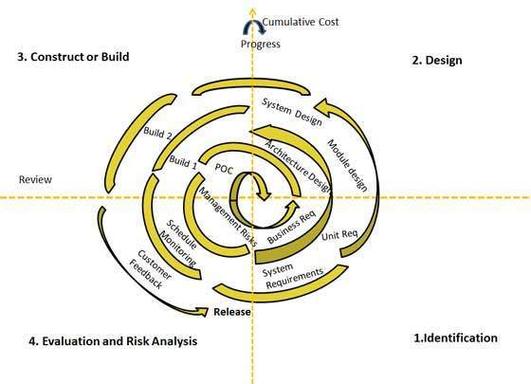

Based on the customer evaluation, software development process enters into the next iteration and subsequently follows the linear approach to implement the feedback suggested by the customer. The process of iterations along the spiral continues throughout the life of the software.

## Spiral Model Application

Spiral Model is very widely used in the software industry as it is in synch with the natural development process of any product i.e. learning with maturity and also involves minimum risk for the customer as well as the development firms. Following are the typical uses of Spiral model:

* When costs there is a budget constraint and risk evaluation is important.
* For medium to high-risk projects.
* Long-term project commitment because of potential changes to economic priorities as the requirements change with time.
* Customer is not sure of their requirements which is usually the case.
* Requirements are complex and need evaluation to get clarity.
* New product line which should be released in phases to get enough customer feedback.
* Significant changes are expected in the product during the development cycle.